Faculty of Computing
Class: BSCS-2023
Section:
Course: CS-346 Compiler Construction

Lab 00: Lab Topic
Date: 15 / 09 / 26

Lab Instructor: Ms. Urooj Akmal
Student Name: Abdul Rehman Riaz
Lms Id: 542715

Github Repo Link:

https://github.com/SolitaryRehman/DSA-Labs

Introduction
This lab introduces arrays, pointers, and dynamic memory allocation in C++ through practical programming tasks.

Objectives
To understand and implement static and dynamic arrays, pointer expressions, 1D and 2D arrays, dynamic memory allocation, resizing, and safe memory deallocation in C++.

Tools/Software Requirements
Vscode
Github

Lab Tasks

Task 1:
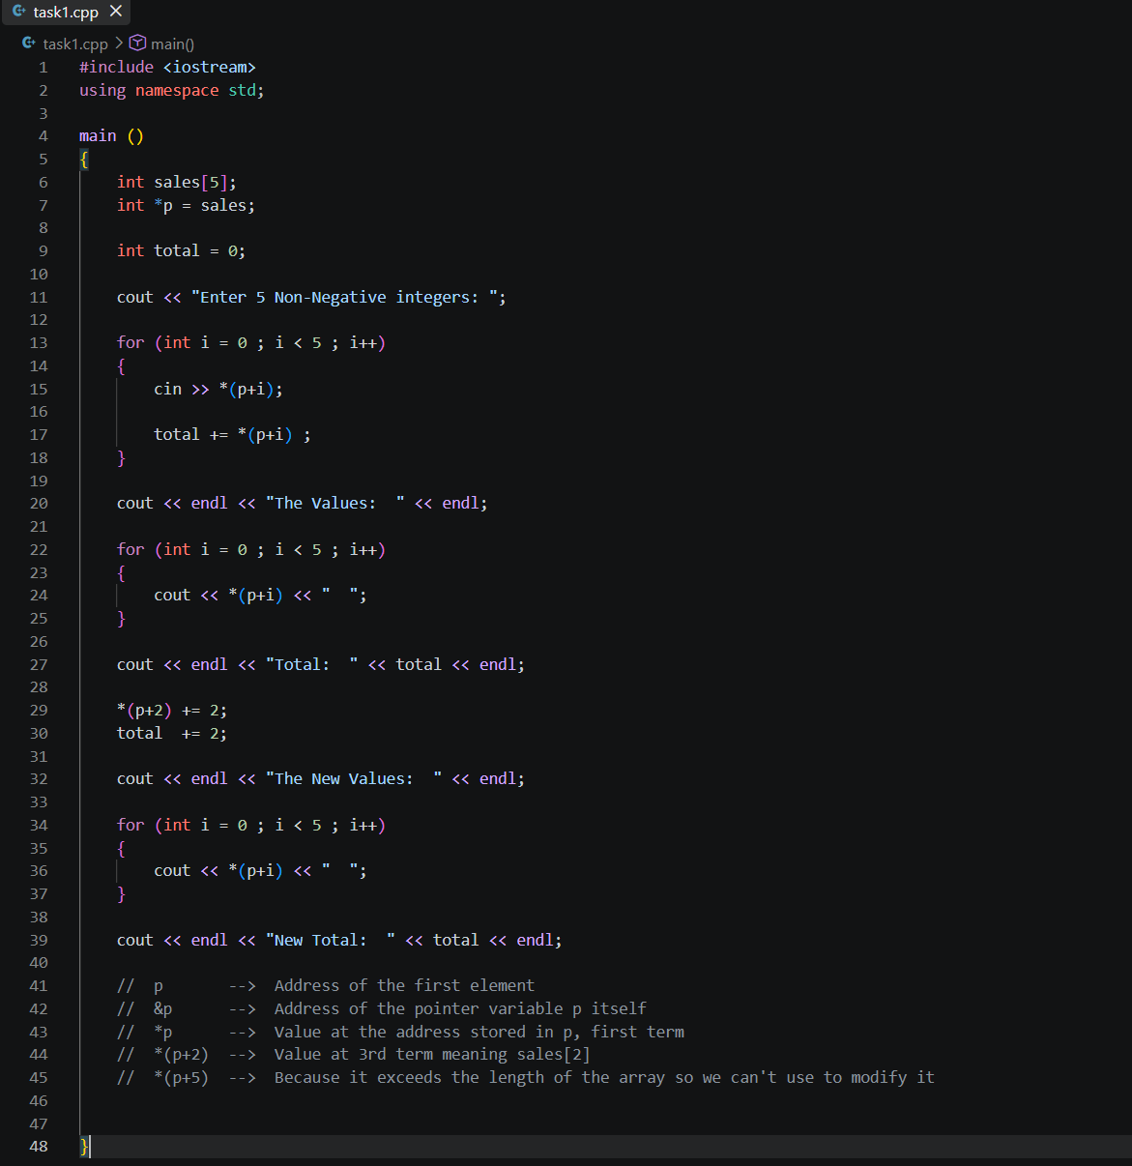
Explanation:

Store sales for 5 days using an array and pointer, then update the third day's sales.
“p” stores the address of the first value. Valid indexes are 0–4; p + 5 is outside the array
Output:
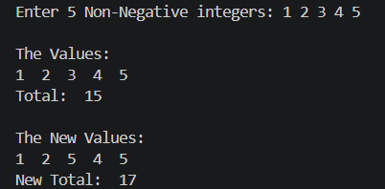

Task 2:
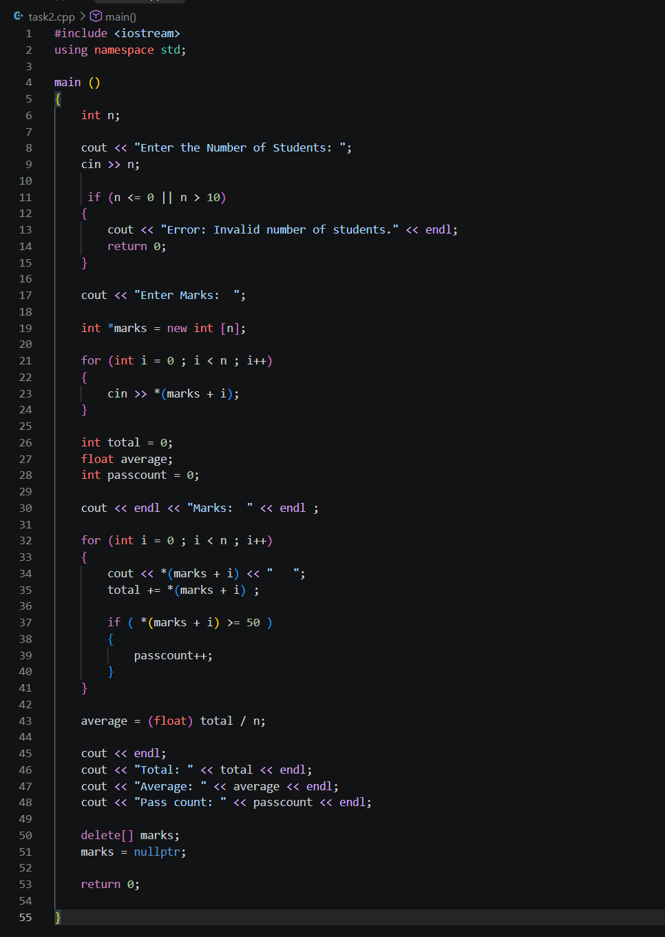

Output:
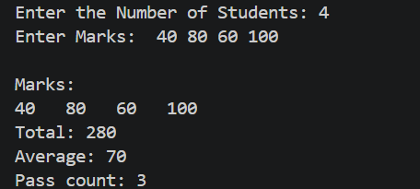

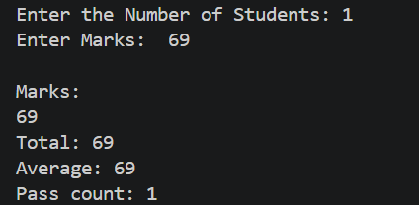

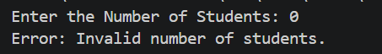

Explanation:

Create a marks array based on the number of students and find the total, average, and pass count.
new int[n] can create an array using a runtime size. int marks[n] is not standard C++ when n is entered at runtime.

Task 3:
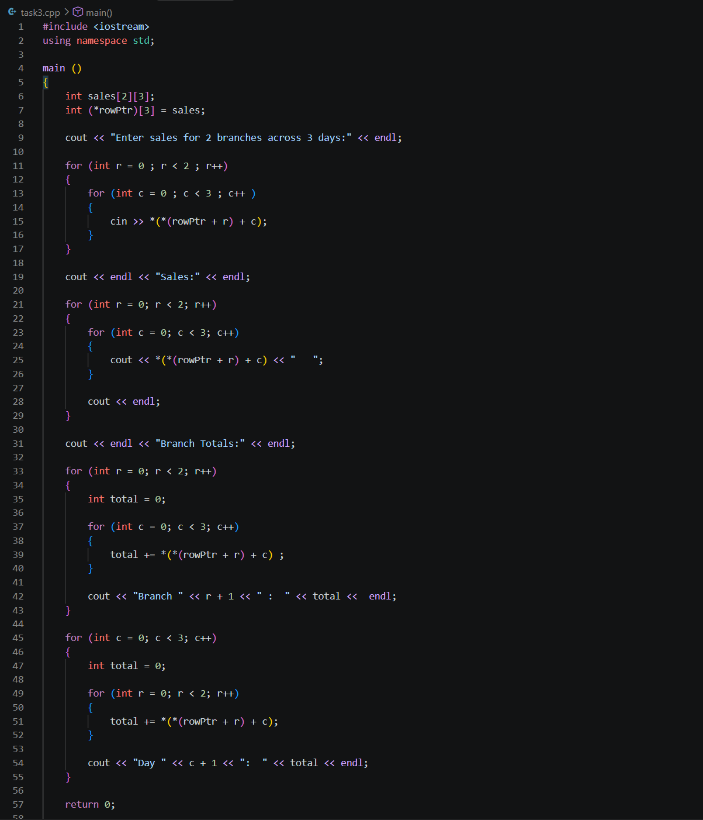

Output:

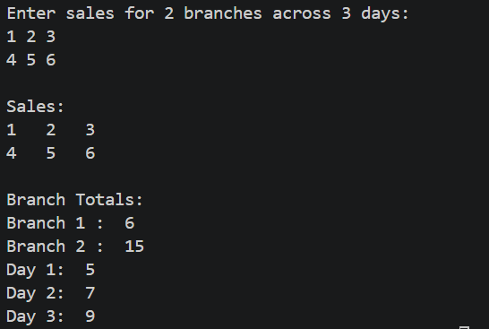

Explanation:

Store sales for 2 branches and 3 days, then find branch and day totals.
rowPtr + 1 moves to the next row. int** is not correct for this type of normal 2D array.

Task 4:
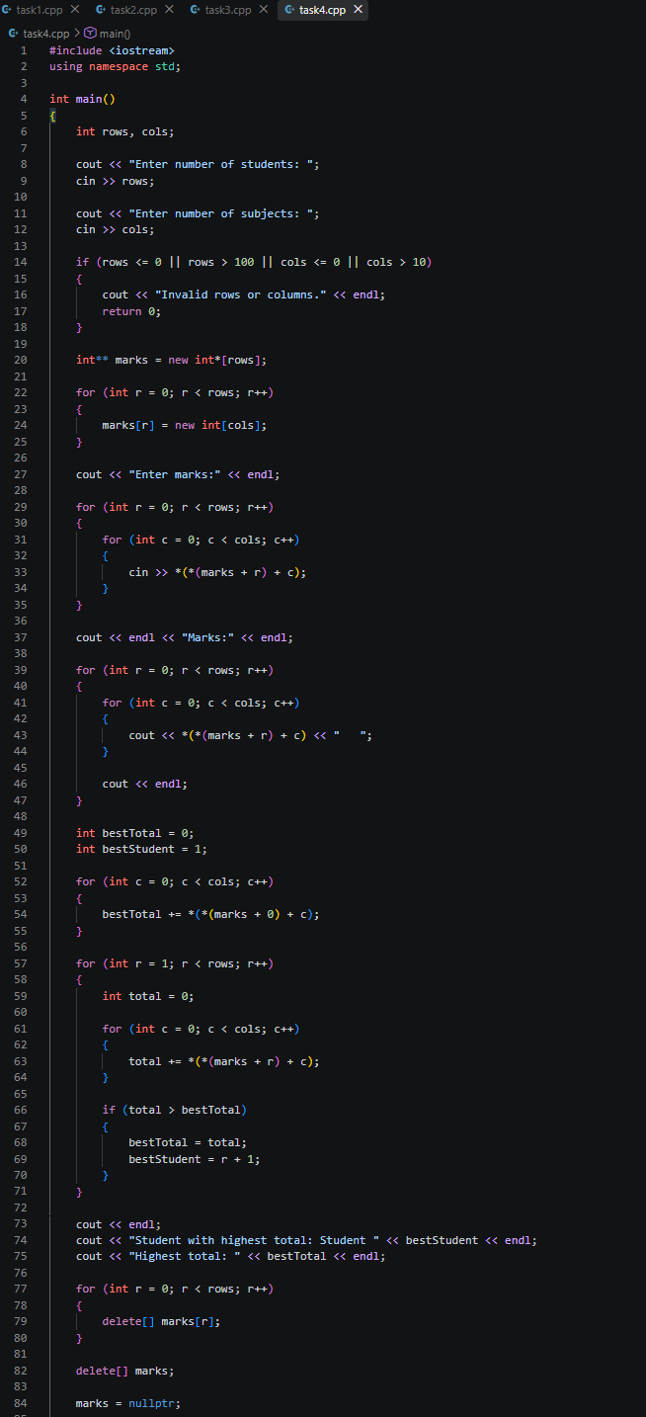

Explanation:
Create a dynamic marks table for students and subjects and find the student with the highest total.
marks points to the row pointers, while marks[0] points to the first row. Every allocated row must be deleted to prevent memory leaks.

Output:
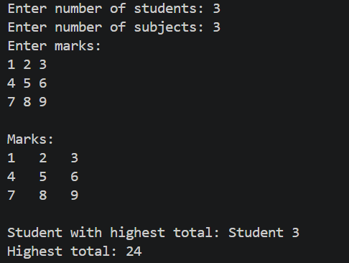

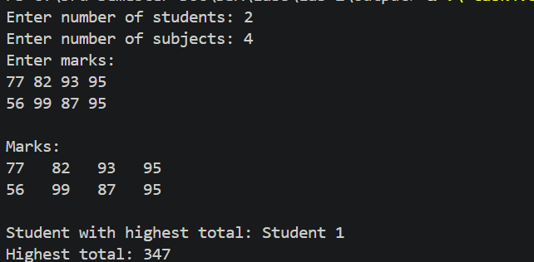

Task 5:
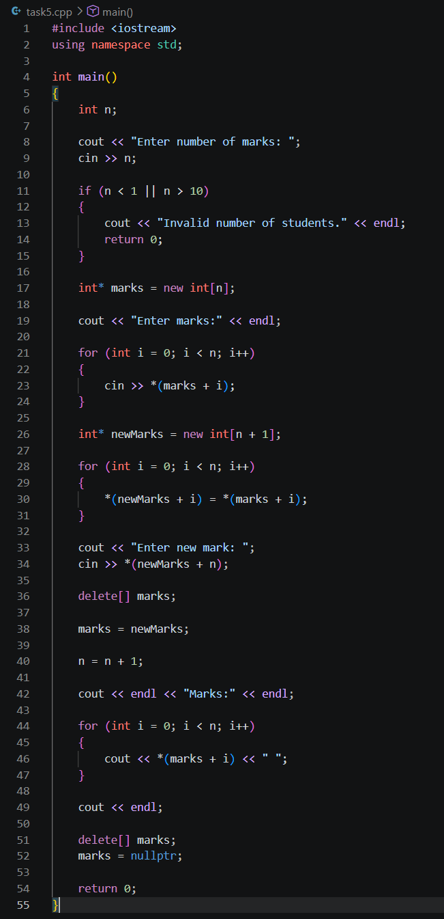
Outputs:
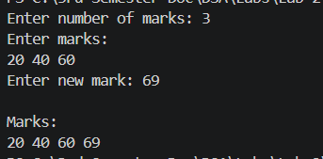
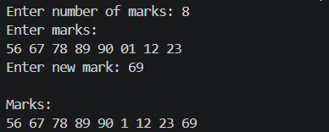
Explanation:
Add one more mark by creating a bigger array and copying the old values into it.
Increasing n does not increase the old array's size. A new, bigger memory block is needed.

Task 6:
Errors:
- Out-of-bounds access:
“for (int i = 0; i <= n; i++)” should be like “for (int i = 0; i < n; i++)”
- Incorrect Deletion:
“delete values” should be like “delete[] values”

- Using a dangling pointer:
“cout << values[0];” is wrong because values has already been released.
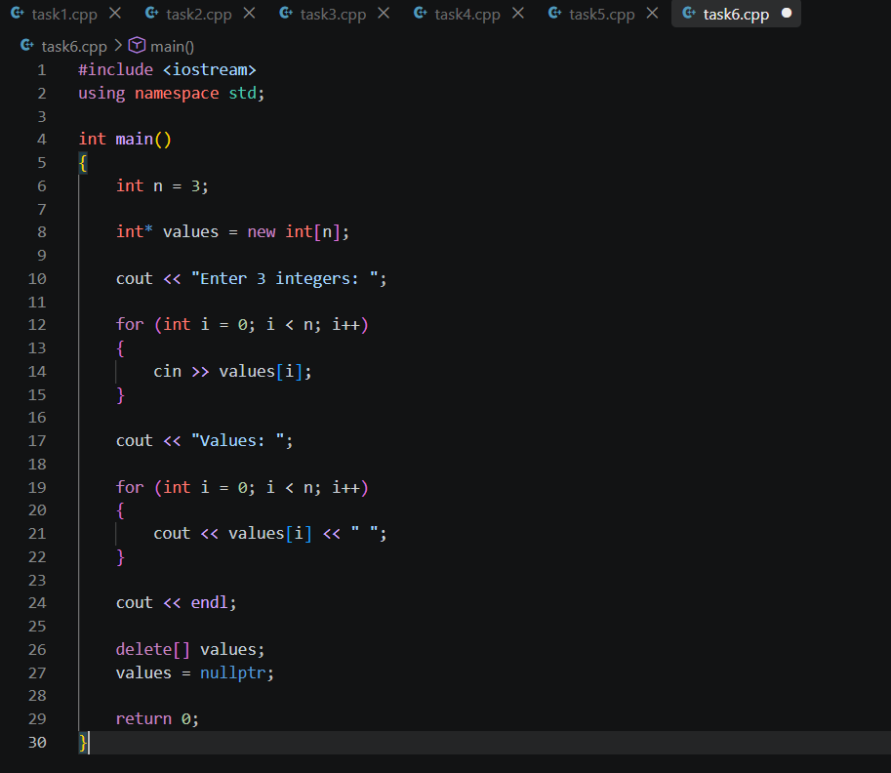
Output:
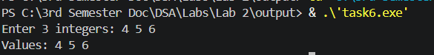
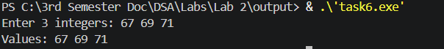
Explanation:
Find and fix errors related to array limits, deleting memory, and pointers.
Out-of-bounds means accessing outside the array, a dangling pointer points to deleted memory, and a memory leak means allocated memory was never released.

